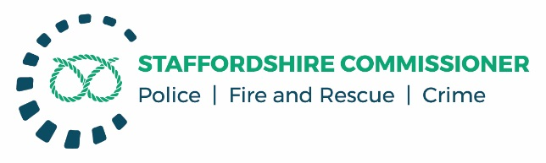

**PUBLIC MEETING**

**PCC PERFORMANCE GOVERNANCE MEETING**

**AGENDA**

Friday 9th November 2018, 09:00 – 11:00.

Oak Room, County Buildings, Martin Street

Stafford ST16 2LH

**SCRUTINY ITEMS**

1. **ACTIONS FROM PREVIOUS MEETING HELD ON 5th May 2018.**

|  |  |  |
| --- | --- | --- |
| **Action No** | **Actions Outstanding and Arising From This Meeting** | **Who** |
| 006 | Resolution Centre - Future agenda item for February 2019. GM will bring back monitoring report on the county-wide operation of the resolution centre during its first 6-9 months. To identify whether it is delivering the level of confidence expected.  **Update 01.05.18** – On Track for delivery of report at the February meeting. | **GM** |
| *007* | Crime Variations (Performance) - GM to provide next meeting with detail behind the variations in crime across the county. Detailed overview of what the trends are in relation to areas and specific plan of action for the crimes that sit behind the figures. To include an understanding of the uplift in vehicle crime, particularly in the South of the county.  **Tabled below.** | **GM** |
| *008* | Anti-Social Behaviour (ASB) - NA to send ME the ASB plan developed for Stoke-on-Trent. Plans for Stoke Central are of particular interest. | **GM** |
| *009* | Assaults on Officers *–* GM to provide a report to the PCC identifying any reasons for the variation in the picture of assaults on officers across the county. | **GM** |
| *010* | Stop and Search and Knife Crime - Report to come back to the next meeting to identify whether there has been further progress on the work of the Force around knife crime.  **Tabled below.** | **GM** |
| *011* | Local Policing and Partnership Working - Examples of problem solving packages to be provided in the refresh of the performance report for the next meeting.  **Tabled below.** | **GM** |

1. **FORCE PERFORMANCE REPORT**

* **Service Offer to the people of Staffordshire**
* **Crime Variations as per Action 007**
* **Local Policing and Partnership Working: Problem Solving Packages**
* **Stop Search and Knife Crime as per Action 010**
* **People Strategy and Gender Pay Gap Report**

1. **DATE OF NEXT MEETING**

Tuesday 12th February 2019, 10:00 – 12:00, Oak Room County Buildings.