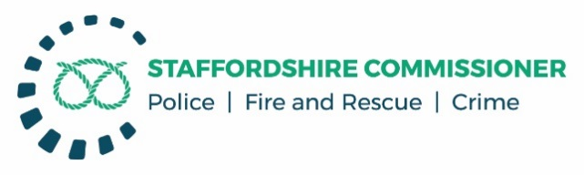

**COMMISSIONER’S PUBLIC PERFORMANCE MEETING - STAFFORDSHIRE POLICE**

**AGENDA**

Thursday 27th January 2022, 13:00 – 15:00 Oak Room, County Buildings, Stafford

**Attendance and Introductions**

1. **Emerging Challenges 13:00 – 13:20**
   1. Chief Constable’s Foreword

**Staffordshire Priorities** including National Crime and Policing Measures (NCPM)

1. **Key Headlines 13:20 – 13:40**
2. **A local and responsive service** 
   1. Contact: Emergency and Non-Emergency
   2. Response: Grade 1 and Grade 2
   3. Tackle Anti-Social Behaviour
   4. Reduce Neighbourhood Crime (NCPM)
   5. Road Safety: Enforcement
3. **Prevent harm and protect people 13:40 – 14:00**
   1. Reduce murder and other homicide (NCPM)
   2. Reduce serious violence (NCPM): inc Domestic Abuse & Violence against Women & Girls
   3. Disrupt drugs supply and county lines (NCPM)
   4. Tackle cybercrime (NCPM)
4. **Support victims and witnesses 14:00 - 14:20**
   1. Victim’s Code of Practice Compliance
   2. Improve satisfaction among victims & witnesses, with focus on victims of DA (NCPM)
   3. Public Confidence
5. **Reduce offending and reoffending 14:20 – 14:40**
   1. Outcomes
   2. Repeat Offending rates
6. **A more effective criminal justice system 14:40 – 14:45**
   1. Criminal Justice - Timeliness
7. **Enabling Services: HR & Finance Update 14:45 – 15:00** 
   1. Operation Uplift, Officer recruitment
   2. Collaboration
   3. Finance

**Date of Next Meeting** Tuesday 26th April 2022, 14:00 – 16:00