

This document is classified as

OFFICIAL

Transparency: Full - proactively published

**Public Performance Meeting**

**27 January 2022**

**Published – January 2022**

**Contents**  Page

1. **Emerging Challenges** 
   1. Chief Constable’s Foreword …………………………………………………………………………………………………………… 3

**Staffordshire Police and Crime Plan** including National Crime and Policing Measures (NCPM)

1. **Key Headlines** ………………………………………………………………………………………………………………………………… 4
2. **A Local and Responsive Service**
   1. Contact and Response: Emergency and Non-Emergency ………………………………………………………………… 5
   2. Response: Grade 1 and Grade 2 …………………………………………………………………………………………………… 6
   3. Tackle Anti-Social Behaviour ………………………………………………………………………………………………………… 7
   4. Reduce Neighbourhood Crime (NPCM)…………………………………………………………………………………………… 7
   5. Road Safety: Enforcement and Community Speed Watch………………………………………………………………… 8
3. **Prevent Harm and Protect People**
   1. Reduce Murder and other Homicide (NPCM) …………………………………………………………………………………… 10
   2. Reduce Serious Violence (NPCM): inc Domestic Abuse & Violence against Women & Girls…………………… 11
   3. Disrupt Drugs Supply and County Lines (NPCM) ……………………………………………………………………………… 13
   4. Tackle Cyber Crime (NCPM) .…………………………………………………………………………………………………………… 14
4. **Support Victims and Witnesses**
   1. Victims’ Code of Practice Compliance……………………………………………………………………………………………… 15
   2. Improve Satisfaction among Victims and Witnesses, with focus on Victims of DA (NCPM) …………………… 16
   3. Public Confidence….……………………………………………………………………………………………………………………… 17
5. **Reduce Offending and Re-offending**
   1. Outcomes …………………………………………………………………………………………………………………………………… 18
   2. Repeat Offending Rates………………………………………………………………………………………………………………… 19
6. **A More Effective Criminal Justice System**
   1. Criminal Justice – Timeliness ………………………………………………………………………………………………………… 19
7. **Enabling Services: HR & Finance Update**
   1. Operation Uplift, Officer Recruitment……………………………………………………………………………………………... 20
   2. Collaboration ……………………………………………………………………………………………………………………………… . 21
   3. Finance .……………………………………………………………………………………………………………………………………… 21

**Emerging Challenges**

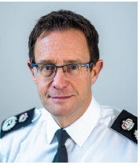**Chief Constable’s Foreword**

In December 2021, I started in my role as the new Chief Constable of Staffordshire Police. It is a privilege and an immense responsibility and I am committed to building on the proud traditions and history of Staffordshire Police. Staffordshire has historically been known as an outstanding local and creative police force that works hand in hand with its partners and communities.

I have commenced the process to develop Staffordshire’s next policing plan, which will be key to delivering on the Commissioner’s new Police and Crime Plan priorities, but there are number of early priorities that I have focused the Force on over the last 6 weeks.

First, I want us to deliver a local police service which is tailored for individuals, families and communities who feel listened to and supported. We are currently developing a new policing model which will see more officers based and addressing challenges in local communities. This will mean officers can respond to emergencies quicker, but it will also allow them to spend more time in the heart of local communities, working with partners to tackle crime at its root cause. The safety and security of our communities is far too important to be left to the police service alone, and effective local partnerships will enable us to solve local issues and prevent crime and anti-social behaviour.

Second, we need to develop a sharper focus on caring for victims. This includes getting even better at dealing with calls and digital enquires, ensuring the most vulnerable victims get justice and bespoke care, or tackling the most harmful offenders in the home, on our streets or across our Force area and beyond.

Finally, I’ve made a clear commitment to care for the staff, officers and volunteers who work for Staffordshire Police. They work under incredibly challenging circumstances, dealing with difficult situations on a daily basis that most of us don’t witness in a lifetime. Ensuring the organisation cares for them and provides them with the right support will ensure they can provide the outstanding service to the public that they passionately want to.

The last 20 months have been challenging for policing and there is no doubt there are many emerging and indeed unseen challenges we will have to face. The challenges of COVID have not ended and we are yet to see the long-term impact on our families, economies and communities.

I believe Staffordshire as a Police Force and a coalition of partners has responded to the pandemic with both commitment and common sense. This I believe has maintained public confidence both in the force and the wider joint commitment of partners, to making our County safer, more prosperous and fairer.

Whilst the peaks of the pandemic saw a significant reduction in crime levels compared to the previous year, since restrictions were lifted in the summer, we’ve seen demand return to and indeed surpass, previous levels. Like all police forces, we’ve seen a significant increase in 999 calls since the summer. July 2021 saw exceptional volumes and while call levels then stabilised in August, September, October and November, they are still at much higher levels than in the previous two years. We will continue to recruit more staff to work in our force control room to deal with this increased demand and they are a key part of my commitment deliver a new and improved approach to local policing.

While not all crime types, such as burglary, theft and the carrying of weapons have increased, worryingly we have seen an increase in sexual offences and public order offences as more people have returned to our towns and cities. Our commitment to tackle all violent crime, but particularly crimes committed against women and girls, has been re-energised as we’ve launched a bespoke Tackling Violence Against Women and Girls strategy which will steer and define the work Staffordshire Police will do to keep women and girls safe. I am also very clear about the standards I expect of my officers and staff – the police service must maintain the highest standards of any organisation because of the unique position of power that it holds. Recent events have fundamentally undermined public and victim confidence in the police service – we need to regain that trust.

Despite this context and these challenges, I have been massively impressed and reassured by the quality and passion of the officers, staff and volunteers who go the extra mile every day to keep the people of Staffordshire safe.

The next year will continue to be challenging and to be clear, we need to do better and be better in serving our communities. However, I am confident that we have the passion, dedication and knowledge to rise to that challenge, and that the public in Staffordshire will be proud of the women and men who serve and protect them every hour of every day in every part of our County.

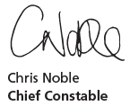

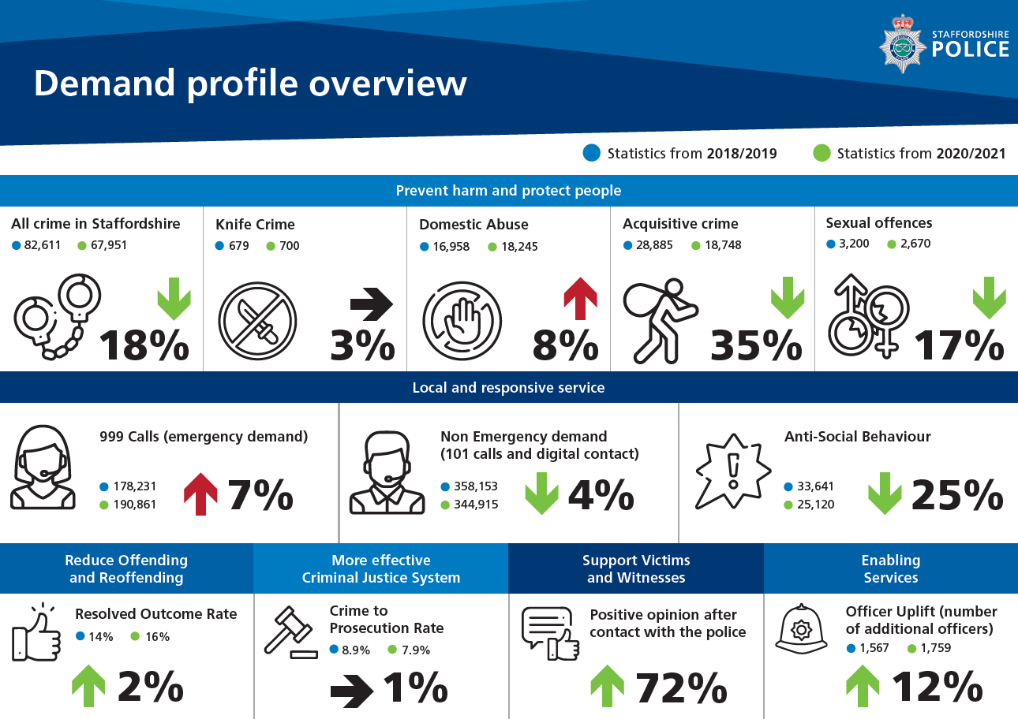

**Staffordshire Police and Crime Plan - A Local and Responsive Service**

**Contact: Emergency and Non-Emergency and Response: Grade 1 and Grade 2**

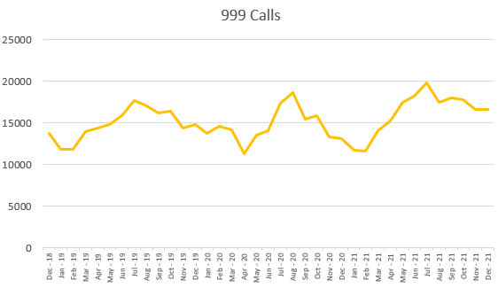

Contact Services covers telephony, digital contact, switchboard, front counters, contact managers, the Missing Persons Investigation Team, as well as support in training and contact systems administration. They handle incoming calls, digital contacts, crime and incidents reported over the national Single Online Home platform and from late April 2021 a new ‘online’ chat service ‘live chat’.

These contacts are classified as emergency, non-emergency, general enquiries and outgoing calls. Contact is also received from other partners and agencies such as ambulance and fire and rescue.

Emergency (999) Calls – Last 12 months (December 2020 to November 2021)

* When comparing these volumes to the same period in 2018/2019 there has been an increase of 7% (12,630).

Non-Emergency Contacts

Members of the public can report a non-emergency incident in a variety of ways such as the Contact Centre (101 calls) and digital platforms (live chat, Facebook, Twitter or Single Online Home).

Last 12 months (December 2020 to November 2021)

* Non-emergency contacts have been fairly stable over the last three years.
* When comparing 101 calls to the same period in 2018/2019, there has been a decrease of -24% (-79,185).

The top five callers have remained the same as the 2018/19 comparison period and are all linked to hospitals. Of the calling numbers in the last 12 months, 13% are landline numbers and 87% are mobile telephone numbers.

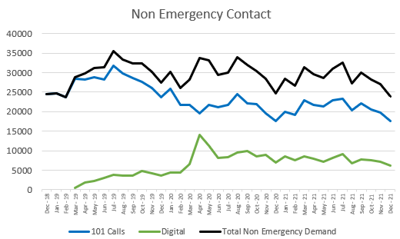

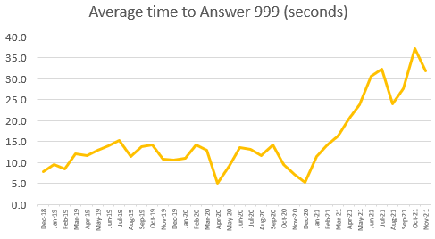

Average Time to Answer:

Emergency (999) Calls – Last 12 months (December 2020 to November 2021)

* Average time to answer emergency (999) calls has increased in the last 12 months from 11.3 seconds to 24.1 seconds.

Non-Emergency Contacts – Last 12 months (December 2020 to November 2021)

* Average time to answer 101 calls has increased in the last 12 months from 591.4 seconds to 614.7 seconds.

Abandoned Calls - Last 12 months (December 2020 to November 2021)

* Abandoned within one minute of joining the ‘control room’ queue; 28% (21,068) of abandoned calls This has remained stable compared to the previous year. This would suggest the caller either chose the digital route through the alternative options messages or made an informed decision to call back later when their position in the queue was provided.

There is an ongoing recruitment programme within Contact Services to help ensure that the right people, with the right skills are in the right place at the right time, new recruits will support the 999 call demand and improvements are expected to be seen by April 2022 onwards.

Response officers respond to incoming calls for service that are identified by the Contact Centre as an emergency (Grade 1) or priority (Grade 2) and which require physical attendance. A resolution centre is also located at each response hub location to support service delivery.

Overall 50% of incidents are resourced and this proportion has remained stable for the last three years.

Response – Last 12 months (December 2020 to November 2021)

Grade 1 Response (Target = Respond within 15 minutes)

* The force has responded to 50% of Grade 1s within 15 minutes.

Grade 2 Response (Target = Respond within 60 minutes)

* The force has responded to 44% Grade 2s within 60 minutes.
* The peak in Apr-Jun 2020 was the result of initial Covid lock-down.

Grade 3 incidents are managed by the neighbourhood teams and the average attendance time (28 hours 30 mins) has increased gradually over the last 12 months (+3 hours 40 mins) and was above average in September and October 2021. The proportion of Grade 3s attended within the 24-hour target is below average in the last four months with 68% attended.

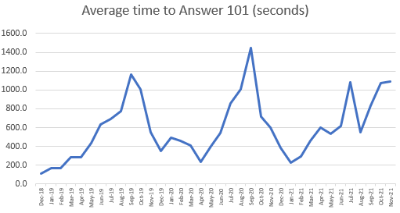

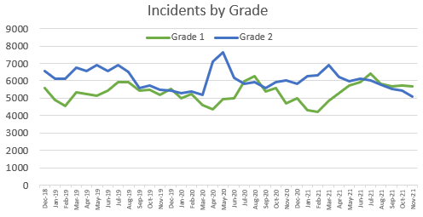

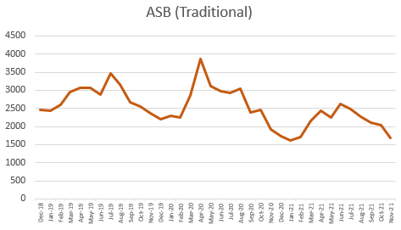**Tackle Anti-Social Behaviour**

Anti-Social Behaviour (ASB) – Last 12 months (December 2020 to November 2021)

* 26% (3,726) of addresses have reported more than one ASB incident a decrease of -3% compared to 2018/2019. 19% (2,816) of addresses have made between two and three reports.

Repeat addresses have been used rather than telephone numbers to calculate repeats for ASB, as some addresses will have multiple telephone numbers which would reduce the proportion of repeats.

Hotspot locations are identified via local knowledge, handovers from previous shifts, monitoring volumes of incidents, regular meetings to raise awareness of ongoing local issues and a daily review by the Harm Reduction Hubs.

Covid has affected the occurrence of ASB and the manner in which it presents with Neighbour disputes increasing due to reductions in social activity.

Work within the Early Intervention and Prevention Unit (EIPU) has focused on multi-agency projects and visits to locations to conduct environmental visual audits at identified hotspots. The summer holiday SPACE scheme funded by the Commissioner’s Office for young people aged eight to 17 continues to be a success, with 5,000 young people attending, despite the challenges of Covid.

**National Definition: -** Acquisitive Crime includes: burglary residential; burglary business and community; personal and business robbery; theft from vehicles; theft of vehicles and theft from a person.

Acquisitive Crime Last 12 months (December 2020 to November 2021)

* Acquisitive crime decreased during the first Covid lockdown (March to July 2020) and although increases have been seen over the summer months, levels are not as high as before Covid.
* When comparing these volumes to the same period in 2018/2019 there has been a decrease of -33% (-3,677).

A key focus in vehicle crime is prevention, with proactive policing, media campaigns, the use of Smart Alerts and working with manufactures to help reduce the opportunities for criminality. Keyless thefts of vehicles are the greatest threat and the public are reminded to protect the keys to keyless vehicles in a faraday bag or metal tin.

Robbery was starting to decrease before the first Covid lockdown in March 2020 and has seen a -32% decrease compared to pre-Covid levels. Personal robbery is part of a neighbourhood policing focus to understand the impact of crimes on communities, and to design out this type of crime. Personal robbery is not as prevalent as in previous years and there have been no significant patterns identified as offending is sporadic.

**Reduce Neighbourhood Crime - National Crime and 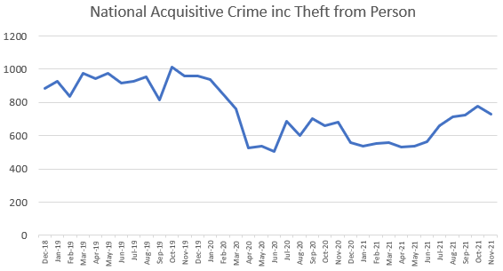Policing Measure**

**Road Safety: Enforcement**

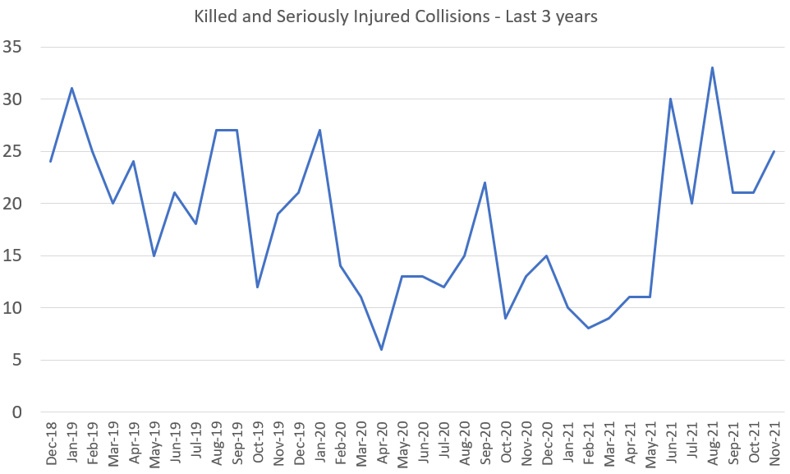

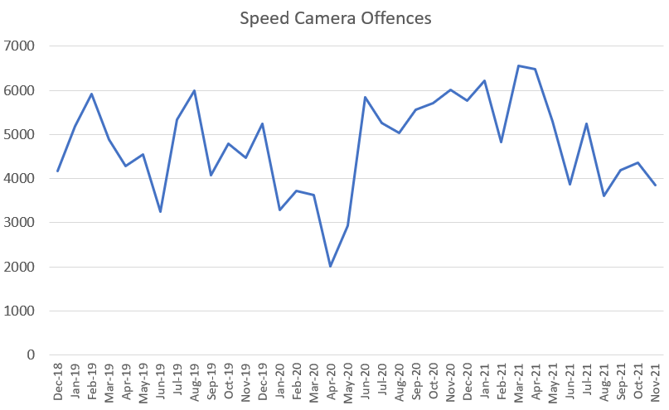

The Roads Policing Unit (RPU) were introduced in September 2019 and since this time resources have increased. RPU are also working more closely with Neighbourhood Policing Teams addressing the concerns of residents in the communities. This includes supporting Community Speed Watch which is now re-starting after Covid-19 restrictions and also targeting areas of criminality such as insecure loads and tachograph offences and proactively policing the roads concentrating on speed, mobile phone, drink/drug driving and seat belt offences (fatal 4), and also utilising Bikesafe to educate riders and enhance biking skills.

Road Safety – Last 12 months (December 2020 to November 2021)

* The force has recorded 214 killed and seriously injured collisions (KSI).

Analysis of fatal collisions over the last 12 months has revealed that:

* The highest number of fatalities were in the age group 25 to 34 years (three car drivers and two pedestrians).
* Over the last 12 months, 71% of all fatalities were male.
* The largest contributory factors in fatal collisions were loss of control, failed to look properly and exceeding the speed limit.
* Of the 21 fatalities in the last 12 months, there were nine car drivers, five motorcycle riders, three passengers and four pedestrians.

After the initial Covid-19 lockdown, there were increases in relation to speed camera offences (from April 20), volumes have since returned to pre Covid levels, although subject to a degree of variance. When comparing these volumes to the same period in 2018/2019 there has been an increase of 6% (3350 enforcements). Implementation of new average speed cameras on the A500 in September 2020 also contributed to increased enforcement.

**Road Safety – Community Speed Watch**

Community Speed Watch is an initiative whereby local residents can help make a difference in their community by helping to reduce the speed that motorists travel through their village or town.

The information captured by Community Speed Watch is used to:

* Send warning letters to drivers in line with the educational remit of policing.
* Identify repeat offenders, high speeds and ‘hotspots’ which helps support the enforcement strategy through Neighbourhood Policing Teams, Roads Policing Unit and safety camera vans.

In 2021, 357 trained volunteers provided over 3,000 hours of activity in support of Community Speed Watch.

From 2016 to 2019, the number of active volunteers and the number of hours of activity have been increasing. The level of activity has been impacted by the Covid-19 pandemic but is now returning to expected levels.

Future development

* Continue to grow the number of areas and groups covered by Community Speed Watch.
* Increase the links with Police Community Support Officers in order to strengthen community engagement within policing.
* Promote the use of volunteers in policing through Corporate Communications.
* Strengthen partnership working and good practice with neighbouring forces who operate Community Speed Watch.
* Involve Community Speed Watch in more road safety operations with Neighbourhood Policing Teams, Roads Policing Unit and safety camera vans.
* Reinstate Focus group meetings with the volunteers.

Volunteer Overview

|  |  |  |  |
| --- | --- | --- | --- |
| **Year** | **Number of Active Groups** | **Number of Active Volunteers** | **Number of Hours at the Roadside** |
| 2016 | 40 | 164 | 463 |
| 2017 | 52 | 251 | 749 |
| 2018 | 69 | 327 | 969 |
| 2019 | 69 | 369 | 1558 |
| 2020 | 64 | 325 | 828 |
| 2021 | 66 | 357 | 1242 |

Volunteer Activity

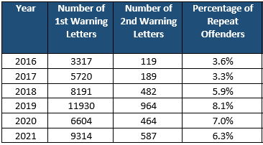

**Staffordshire Police and Crime Plan - Prevent Harm and Protect People**

The Government’s ‘Beating Crime Plan’ July 2021, focusses on three key areas:

* Cutting homicide, serious violence and neighbourhood crime
* Exposing and ending hidden harms and prosecuting perpetrators
* Building capability and capacity to deal with fraud and online crime

It sets out how we will together deliver on our shared vision of fewer victims, peaceful neighbourhoods and a safer country.

Six measures will be introduced to help focus effort on key national priorities, allow performance to be measured and help to demonstrate value for money in policing.

The priority measures are: -

* reduce murder and other homicide
* reduce serious violence
* disrupt drugs supply and county lines
* reduce neighbourhood crime (page 8)
* improve satisfaction among victims, with particular focus on victims of domestic abuse
* tackle cyber crime.

**Reduce Murder and Other Homicide NCPM**

Nationally, homicide will be measured through police recorded information.

**Definition in the ‘Beating Crime’ Plan**:Homicide; the killing of a person at the hand of another and is the most serious crime.

Murders have a devastating impact on the victim’s families and the wider community. Murders across Staffordshire are predominantly committed by people who knew the victim. We have experienced a broad range of murders that range from domestic murder, child murder to drug/criminal dispute related murder. Alcohol, drug misuse and mental health are common factors in murder investigations. Many of these murders are the result of broader social issues and require a long-term holistic approach to breaking the generational cycle of violence. Staffordshire Police together with the Office of Police, Fire and Crime Commissioner, local authorities, health trusts, education, Probation and the voluntary sector have established a Staffordshire and Stoke-on-Trent Violence Reduction Alliance to tackle violence at the root cause.

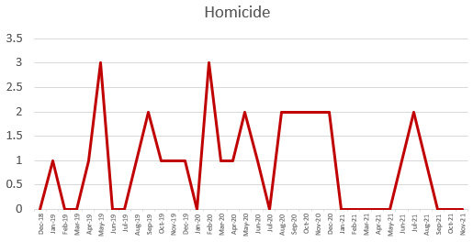

**Reduce Serious Violence - National Crime and Policing Measure**

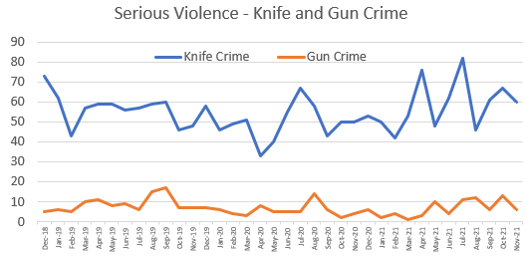

Nationally this will be measured through hospital admissions of under 25s for assault with a sharp object, and police recorded information of offences involving discharge of a firearm. A proxy local measure for knife crime and gun crime is used here to show Staffordshire’s position.

**Definition in the ‘Beating Crime’ Plan**

Serious violence - such as crimes that involve knives or guns which can have life-changing consequences.

**Definition** Knife Crime: Specific violence, sexual offences and robbery crimes involving the use of a weapon that is sharp and capable of piercing the skin, which is not limited to just knives.

Knife Crime - Last 12 months (December 2020 to November 2021)

* Stoke-on-Trent accounts for 45% (315) of Staffordshire’s knife crime and the county accounts for 55% (386).

Gun Crime - Last 12 months (December 2020 to November 2021)

* The force has received 78 gun crimes.

Stoke-on-Trent accounts for 42% (33) of Staffordshire’s gun crime and the county accounts for 51% (40). The remainder 3% (2) is out of force or location unknown. Incidents of serious violence where weapons, often knives or machetes, have been used to cause injury are often linked to criminal disputes linked to drug supply. Staffordshire rarely witnesses firearms discharges, but the continuance of armed disputes with knives and machetes, often in public areas in broad daylight, destabilises our communities and has resulted in us launching several targeted operations to tackle those groups who present the highest risk.

**Reduce Serious Violence: Domestic Abuse and Violence against Women and Girls**

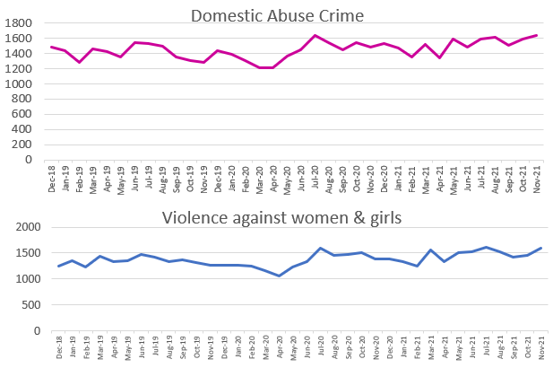

This is the force's current performance information:

Domestic Abuse Crime - Last 12 months (December 2020 to November 2021)

* The force has received 18,245 domestic abuse crimes.
* Stoke-on-Trent accounts for 37% (6,713) of Staffordshire’s Domestic Abuse crime and the county accounts for 64% (11,655).

Domestic abuse levels have remained stable for the last four years. From February 2021 the force implemented Op Encompass, which notifies schools of children living with, or exposed to domestic abuse. Schools have been notified of over 5000 children. The next steps are to implement to Domestic Abuse Act which requires children to be recognised as victims of domestic abuse in their own right and we are working with partners to ensure we have the right pathways and services available.

Violence against women and girls is a national and local priority. A national outcomes and performance framework will be published by 31st March 2022 to sit alongside the delivery framework. The framework will then be developed in consultation with policing, PCCs, other criminal justice system agencies, government and the third sector to ensure shared understanding of;

* Current benchmark and outcomes for one year, two years and beyond.
* Measures to best allow monitoring of progress.
* Data already collected elsewhere.
* What good looks like.

As an interim, this slide focuses on violent crime and does not involve sexual offences and shows violence against the person crimes where the victim’s gender is recorded as female.

Violence against women and girls - Last 12 months (December 2020 to November 2021)

* The force has received 17,497 crimes of violence against women and girls.
* Stoke-on-Trent accounts for 35% (6,200) of Staffordshire’s violence against women and girls and the county accounts for 65% (11,374).

Further work is ongoing to provide a data for January to March 22 to focus on the key areas of practice related to actions set out in the national delivery framework.

The force aims to improve services and partnership working to prevent violence, protect those who feel unsafe and to bring justice to those affected. The problem cannot be solved by policing alone and requires a wider societal response and commitment to improve the lives and experiences of women and girls.

**Disrupt Drugs Supply and County Lines**

Nationally this will be measured through police recorded drug-related homicides and Public Health England Police Referrals into drug treatments.

Organised Criminal Groups (OCGs): Staffordshire Police currently has a number of mapped organised criminal groups (OCGs) of which 52% are located within the Stoke-on-Trent area. The primary activity of most mapped OCGs is drug supply/production.

**Definition County Lines:** Gangs and organised criminal networks involved in exporting illegal drugs into one or more areas within the UK, using dedicated mobile phone lines. They are likely to exploit children and vulnerable adults to move and store drugs and money and use coercion, intimidation, violence and weapons.

Most acts of serious violence involving knives or other bladed weapons are linked to drugs disputes. The force identifies around 100 County Lines per year with approximately 20-25 lines running into the County at any one time.

The force’s County Lines Management Model is considered national best practice and has been shared by West Midlands Regional Organised Crime Unit (ROCU) with other national agencies and UK policing.

The force’s Serious Violence Strategy sets out the response to identify those at risk of entering criminality as a victim or an offender, particularly addressing the issues identified with County Lines and drugs supply, working in partnership to understand causes and consequences and involving a wide range of agencies.

Since October 2019 an additional £292,000 of Home Office funding has been secured by the force to improve our response to intelligence gathering and enforcement.

Comparison with two other forces in the region shows Staffordshire have secured roughly five times the funding allocated to the other forces. Robust management, intelligence development, intervention, supported by proactive policing, has produced some outstanding results for Staffordshire.

Headlines of successes in 2020/2021:

* 17 adults and eight under 18s safeguarded.
* Seizures of drugs: heroin, crack cocaine and cannabis plants.
* 105 charges.
* Four National Referral Mechanism (NRM) referrals for modern slavery.

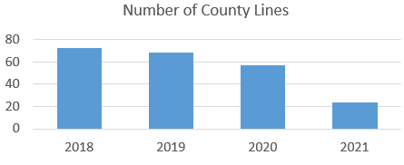

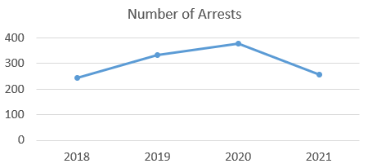

**Geographical Impact**

Stoke-on-Trent and Newcastle have historically been impacted upon by county lines originating from Merseyside. During the last 12 months there have been several joint operations with Merseyside Police which were successful. Areas in the south of the county such as Burton, Tamworth, Stafford, Rugeley and Lichfield are impacted by county lines emanating from West Midlands area.

**Cannabis Cultivation**

The force continues to tackle the increase in organised cannabis cultivation. This involves a partner-led approach to better tackle the crimes and coordinate the collective response, to make Staffordshire a hostile environment in relation to such criminality.

**Tackle Cyber Crime**

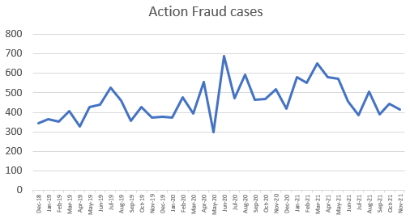

Nationally this will be measured through Cyber Aware Tracker and the Department for Digital, Culture, Media and Sport survey.

**Definition in the ‘Beating Crime’ Plan:**

Fraud **-** techniques used by fraudsters have a widespread impact. It includes the security of our online activity (e.g. fraudulent messages claiming to be from Government or business). Fraudsters are quick to adapt to change and exploit weaknesses in new systems or new technologies.

Cyber Crime **–** stealing personal information or hacking into business systems to use as ransom or disruption.

Staffordshire is using a local proxy measure to measure Cybercrime which incorporates cyber dependent crimes which are managed nationally by the City of London Police and they disseminate investigations through Action Fraud, and cyber enabled crimes which are crimes owned by Staffordshire which have a cyber/online element to them.

This is the force's current performance information:

Fraud **-** Last 12 months (December 2020 to November 2021)

* 5,948 Action Fraud cases were reported by Staffordshire residents to Action Fraud (managed by City of London Police) and, of these, the force received 783 back from Action Fraud to assist with local investigations.
* This is approximately 16 cases and two investigations per day or five cases and 0.7 investigations per 1,000 population.
* You can see on the charts, Action Fraud cases have gradually increased over the last three years, whereas investigations vary and have stabilised in the last 16 months.
* When comparing these volumes to the same period in 2018/2019, there has been an increase of 24% (1,142) in Action Fraud cases reported by Staffordshire residents and a decrease of -31% (-356) Action Fraud investigations.

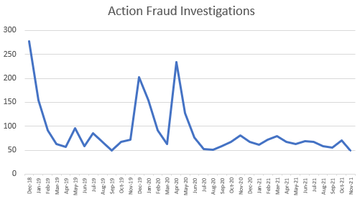

**Staffordshire Police and Crime Plan - Support Victims and Witnesses**

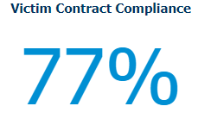 **Victims’ Code of Practice Compliance**

In April 2021, the new Victims’ Code (VCOP) was implemented nationally, this places an onus on police forces to ensure that the victim’s voice and rights are considered from the reported incident up until court or other outcome. From May 2021, the force has been able to report on officer compliance with the victim’s code, through the completion of a victim’s contract.

The Victim Contract covers provision of information under the Victims’ Code of Practice to the victim and also a needs assessment in relation to vulnerability and requirements.

Victims’ Code of Practice is well established within the force, completion of victims’ contracts are part of our culture across all sections of the force.

The force plans to introduce an automated text message service which will automatically send a text message to the victim providing details of the investigating officer, crime number and crime being investigated. The system will also automatically update the victim if the crime is reallocated to a new investigating officer. This process is due to go live in early 2022.

The force has faced some challenges in relation to the transfer of victim’s data to the Staffordshire Victims Gateway; this is completed when the crime is validated in accordance with National Crime Recording Standards/Home Office Counting Rules. This process is currently taking 10 days against a target of 2 days. The force is recruiting additional staff to address this and are also prioritising the crimes based on vulnerability and harm with resolution planned in the next few months. In addition, victims can be referred directly to services by the investigating officer and they are provided with a booklet or digital link containing their rights under the code and contact details for the support services.

The force recognises the importance of understanding the impact good victims code compliance has on the victim experience. Satisfaction data aids understanding of the quality of service and combined with received complaints, the force aims to verify by analysing data, that good contract compliance translates into good victim satisfaction.

Data as at 21st January 2022

30,508 Victim Contracts

39,734 Occurrences

(Multiple occurrences for the same victim will only have 1 victim contract)

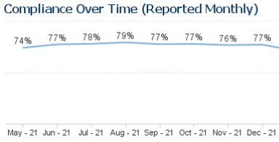

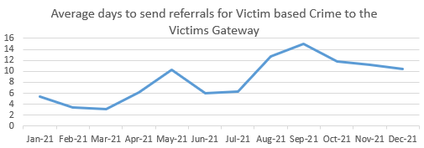

**Improve Satisfaction among Victims and Witnesses, with a particular focus on Victims of DA**

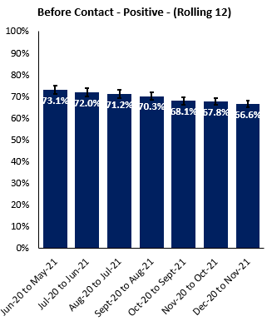

Nationally, this will most likely be measured through the Crime Survey England and Wales.

The force measures victim satisfaction through a locally designed survey and on a rolling 12-month basis. The surveys are based on victims of certain crime types and anti-social behaviour.

A new domestic abuse survey has been designed and will commence shortly.

This is the force's current performance information:

Last 12 months (December 2020 to November 2021)

* 67% of victims had a positive opinion before contact with the force.
* 72% of victims had a positive opinion after contact with the force.
* 86% of victims found it easy to contact the force.
* 90% of victims stated they were satisfied with their follow-up contact.
* 73% of victims stated they were kept informed overall.
* 75% of victims stated they were satisfied with the investigation.

The force has established levels of satisfaction performance with the current operating model. During 2022, the force will transition to its new operating model, and victim satisfaction levels will be one of the indicators to measure success.

The force has an opportunity to request three bespoke commissioned surveys, these could focus on a specific crime type, gender or route to justice, identified by the force as priority.

One of these plans is to take a holistic view of the local criminal justice process and contributing agencies, which will test service delivery from the initial police report to finalisation at court. This will test not only policing service delivery but also the wider criminal justice partners. Work is underway with key partners to agree a question set in early 2022. In the interim we will continue to survey victims whose cases have been finalised at court.

Before Contact – Positive opinion

After Contact – Positive opinion

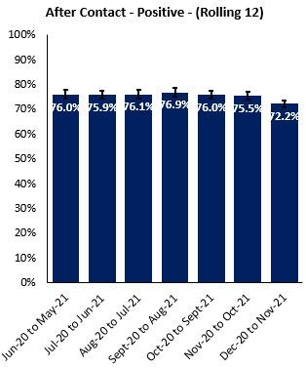

Kept Informed Overall – Positive opinion

Follow-up Contact – Positive opinion

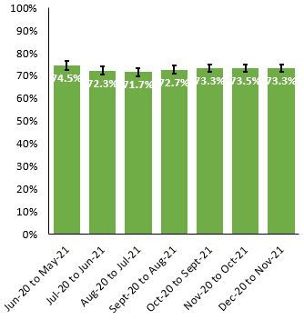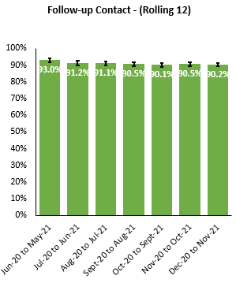

**Public Confidence**

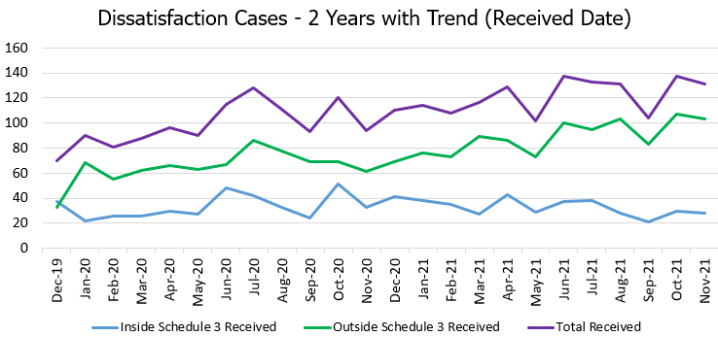

New IOPC statutory guidance was introduced in February 2020 to allow for expressions of dissatisfaction to be dealt with in a more effective and timely manner. These encouraged organisations to move away from a punishment type approach to that of a learning environment.

There is an upward trend in total cases of dissatisfaction. The new regulations required a wider range of dissatisfaction to be recorded or logged, and complaints are described as Inside or Outside Schedule 3:

* Inside Schedule 3 is a recorded complaint or investigation, with a right to review to the local policing body or the IOPC.
* Outside Schedule 3is a logged complaint. The allegation if proven must not justify misconduct proceedings and there is no Right to Review.

The Local Police Review Body (LPB) is the OPFCC and this duty falls to the Compliance Manager. This relates to complaints recorded Inside Schedule 3, which gives a right of review to either the Local Police Review Body (LPB) or the Independent Office for Police Conduct (IOPC). Any learning identified via the reviews is recorded and shared with relevant departments.

Last 12 months (December 2020 to November 2021)

* 1450 complaints recorded in the Professional Standards Department (PSD).
* 779 complaints (54%) retained and triaged within the Professional Standards Department (PSD).
* 65 Local Police Review Body (LPB) decisions.
* 40 conduct matters were recorded.

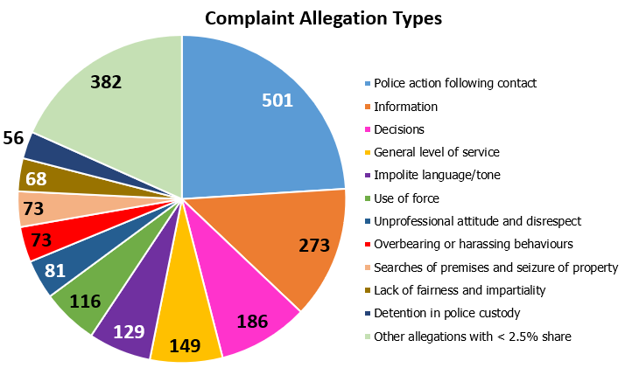

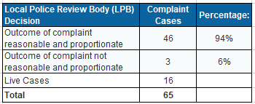

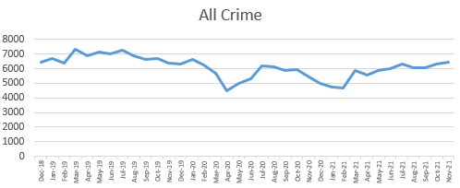**Staffordshire Police and Crime Plan - Reduce Offending and Re-offending**

**All Crime**

During the COVID period and especially during periods of lockdown, the pattern of crime changed and volumes have reduced in a number of areas.

* Acquisitive crime down by -35%.
* Sexual offences down by -17%.

These reductions are likely to have been affected by the restrictions put in place during the pandemic and as a result have impacted the proportions of overall crime.

Volumes of outcomes have reduced in the last 12 months compared to the 2018/19 baseline. It is important to remember that the overall crime rates are also 18% lower during the last 12 months compared to the pre-COVID baseline, with the reduction in outcomes corresponding to the reduction in crime.

Resolved outcomes relate to any positive resolution to a crime, this includes charges and summonses and resolutions which do not require a court hearing such as out of court disposals. These may be in the form of a caution or community resolution.

In December 2019, a new outcome category was introduced to provide an alternative to formal prosecution (Outcome 22: diversionary, educational or intervention activity). This outcome is being utilised increasingly and now accounts for an increasing proportion of the resolved outcomes (5.3% in November).

This is the force's current performance information and is based on rates, rather than volumes for a more balanced comparison: -

Last 12 months (December 2020 to November 2021)

* In the last 12 months, the resolved outcome rate in Staffordshire has increased to 16.2%, an increase of 4.8% compared to the previous 12 months.
* In the last 12 months, the outcome 16 (complainant declined to prosecute) rate in Staffordshire has increased to 27.1%, an increase of 1.3% compared to the previous 12 months.
* In the last 12 months, the unable to progress the investigation outcome rate in Staffordshire has decreased to 53.0%, a decrease of -6.4% compared to the previous 12 months.

Unable to Progress Investigation includes: Crimes with no identified suspect; suspect has been identified but there are evidential difficulties; and crimes which are not in the public interest to prosecute.

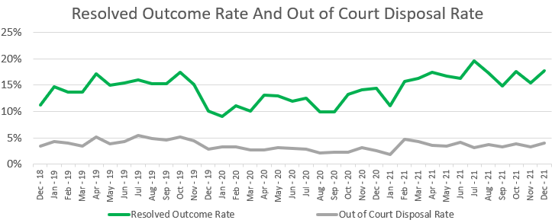

**Outcomes**

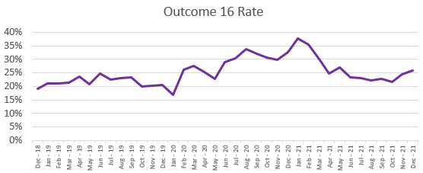

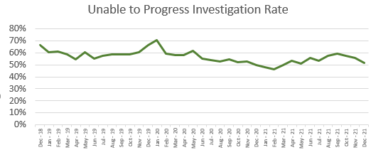

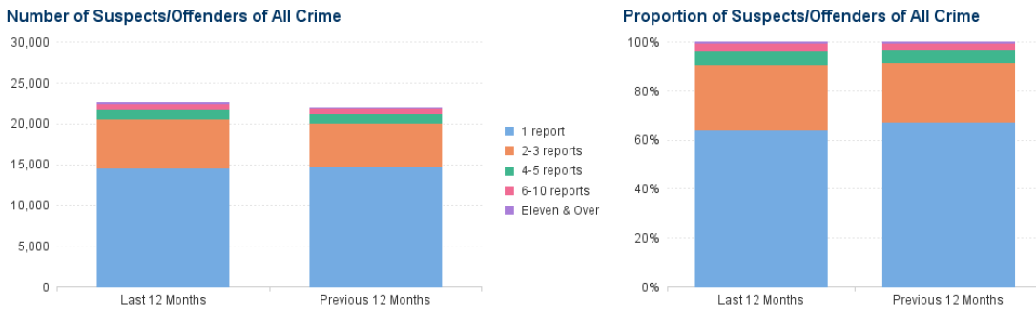**Repeat Offending Rates**

This is the force's current performance information for all suspects and offenders:

Last 12 months (December 2020 to November 2021):

The table shows that of all crimes recorded in Staffordshire with a named suspect or offender, 64% of the suspects or offenders were not repeat offenders.

In the last 12 months there has been an increase in the proportion (+3%) of offenders committing two to three crimes, and a reduction in the proportion (-3%) of offenders committing a single crime. There is no change to the proportion of offenders in the higher volume groups although volumes have increased slightly.

1 report relates to a single crime committed by a named offender in a 12 month period. All other frequency bands relate to repeat offenders, as the definition of a repeat offender is 2 or more crimes within a 12 month period.

**Staffordshire Police and Crime Plan - A More Effective Criminal Justice System**

**Criminal Justice - Timeliness**

The National Criminal Justice System Scorecard was launched in Autumn 2021 and this scorecard will also start to include localised data from April 2022.

Local data from the Crown Prosecution Service (CPS) has been used to understand criminal justice and its timeliness in Staffordshire. The information for crime to court and crime to conviction at court is based on rates, rather than volumes for a more balanced comparison.

This is the force's current performance information: -

Last 12 months (December 2020 to November 2021)

* 7.9% of all crimes are prosecuted at court which has decreased slightly (-1%) compared to the 2018/19 baseline.
* 6.8% of all crimes end in a conviction at court which has decreased slightly (-0.8%) compared to the 2018/19 baseline.
* Improving picture for pre-charge consultation average timeliness with the last 12 months a stable picture of 16 days, this is within the service level agreement of less than 21 days.
* Finalised cases have decreased compared to the 2018/19 baseline, but have increased from 2019/20 when the impact of Covid was seen in the courts.

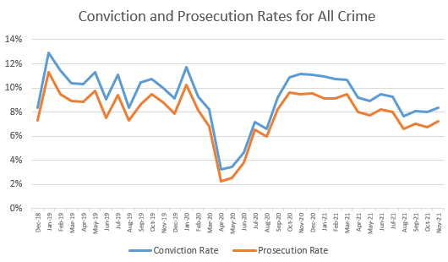

Covid impact on Courts

**Staffordshire Police and Crime Plan - Enabling Services: HR & Finance Update**

**Officer Uplift, Officer Recruitment**

Staffordshire’s allocation from the national 20,000 increase in police office numbers over three years is a total of 300, broken down over the following years:

* 2020/21 – 90 (60 in 2020/21 plus 30 in 2019/20)
* 2021/22 – 90
* 2022/23 – 120 assumed

A total of 375.5additional FTE officers is currently projected at the 31 March 2023 compared to 31 March 2019, prior to Uplift. These additional officer numbers are inclusive of Precept Investment-funded posts as well as the Uplift.

The time to train new student officers is three years under the Police Constable Degree Apprenticeship (PCDA) and two years under the Degree Holder Entry Programme (DHEP). During the training period, student officers should achieve independent patrol status at 40 weeks and therefore be deployable as an independent resource; prior to the 40 weeks, they will be partnered with a tutor constable.

**Workforce Diversity**

Ethnicity:

In Staffordshire as of 31.12.2021 the force employs the following breakdown of black, asian and minority ethnic colleagues compared to the local population of 5.9%;

* Police Officers 4.2%
* Police Staff 3.4%
* Special Constabulary 4.1%

On average in the last 3 years, 5.3% of new colleagues joining the force are of black, asian and minority ethnicities.

Gender:

In Staffordshire as of 31.12.2021 the force employs the following breakdown of genders (compared to the female population of 50.2%);

* Police Officers - 67% male and 33% female - an increase of 4% of female police officers in the last year.
* Police Staff - 37% male and 63% female – a decrease of -2% of female police staff in the last year.

The force’s female representation shows an improvement during the last 12 months to 42.6%. On average in the last 3 years, 36.5% of new colleagues joining the force were female.

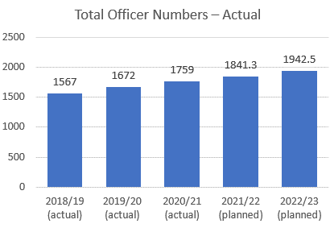

**Collaboration**

The force has continued to work with the Commissioner and Staffordshire Fire and Rescue Service on delivering the Commissioner’s priority of closer collaboration with the fire service. The Commissioner has set a clear direction around further increase of shared estate with the fire service with plans being drawn up to see a move into a single hub in Uttoxeter, following the success of shared hubs in Tamworth and Hanley. In relation to shared enabling services, the force and the fire service will review these, as part of a planned review, in 2022/23.

**Finance**

Overall, the force has continued to live within its means in year, forecasting a modest underspend for the 2021/22 year. This comes alongside the challenges arising from the pandemic as well as maintaining and delivering in full on the uplift programme. The Commissioner is due to present his 2022/23 MTFS to Police, Fire and Crime Panel at the end of January 2022. The force has worked with the Commissioner in developing this and the Commissioner will set out his proposals, drawn up in conjunction with the force at that meeting.