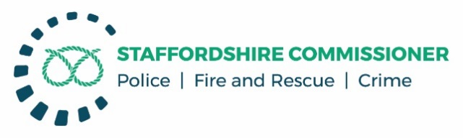

**PUBLIC MEETING**

**COMMISSIONER’S PERFORMANCE GOVERNANCE MEETING**

**AGENDA**

Monday 23rd November 2020, 10:00 – 11:30

Webcast via TEAMS

**SCRUTINY ITEMS**

1. **FORCE PERFORMANCE REPORT**
2. **Performance Monitoring Report – Overall Strategic Performance Summary**

**Focus Areas:**

* + **Public Confidence during Covid 19**
    - **ASB**
    - **Crime**

* + **Modern Policing**
    - **Operation Uplift**
      * **Recruitment and Retention challenges**
      * **Approach to disproportionality in the workforce**

1. **DATE OF NEXT MEETING**

February 2021 TBC