General Notice of Registrable Interests Date:__21 May 2025

Notifications of Disclosable Pecuniary Interests

Employment: Police Fire and Crime Commissioner

- Details of any employment, office, trade profession for profit or gain by me or my partner

Director of Request Systems Limited and ABSR Limited and JABA Associates Ltd.

Sponsorship:

- Any payment or provision of any other financial benefit (other than from the elected local policing body) made or provided within the relevant period in respect of any expenses incurred in carrying out duties and responsibilities, as of a Police or Deputy Police and Crime Commissioner, or towards the election expenses of the Staffordshire Commissioner or Deputy Staffordshire Commissioner. This includes any payment or financial benefit from a trade union within the meaning of the Trade Union and Labour Relations (Consolidation) Act 1992(a).

NONE

Contracts:

- Any contract which is made between the relevant person (or a body in which the relevant person has a beneficial interest) and the elected local policing body –

(a) under which goods or services are to be provided or works are to be executed; and

(b) which has not been fully discharged

NONE

Land:

- Details of any beneficial interest that I or my partner has in land within ELPBA that entitles me or my partner to occupy (alone or jointly with another) that land, or to receive income from it.

NONE other than main residence

Licences:

- Details of any licence that entitles me or my partner (alone or jointly with others) to occupy land in ELPBA for a month or longer.

NONE

Corporate tenancies:

- Details of any tenancy where, to my knowledge, (a) the ELPBA is the landlord; and (b) the tenant is (i) a firm in which I (or my partner) is a partner, (ii) a body corporate of which I (or my partner) is a director, or (iii) (i) a firm or a body corporate that in the securities of which I (or my partner) has a beneficial interest.

NONE

Securities:

- Details of beneficial interest that I or my partner has in the securities of a body where (a) that body (to my knowledge) has a place of business or land in the ELPBA; and (b) either (i) the total nominal value of the securities that I or my partner has exceeds £25,000 or one hundredth of the total issued share capital of that body; or (ii) if the share capital of that body is of more than one class in which I or my partner has a beneficial interest exceeds one hundredth of the total issued share capital of that class.

NONE

Any other unremunerated interests or membership:

- This could include any formal roles within charitable organisations, school governors etc.

Trustee of Police Arboretum Memorial Trust

Gifts and Hospitality:

- The interests of any person from whom the relevant person has received a gift or hospitality with an estimated value of at least £25.

NONE

DECLARATION

I {insert Name}, {insert Role} recognise that it can be a criminal offence to:

(i) omit the information which ought to be given in this notice:

(ii) provide information which is materially false or misleading;

(iii) fail to give further notices in order to:

- bring up to date information given in this notice

- declare an interest which I acquire after the date of this notice and have to declare.
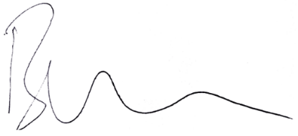

Signature: Date: 21/05/2025

Witnessed by: Louise Clayton

Name & Role: Chief Executive
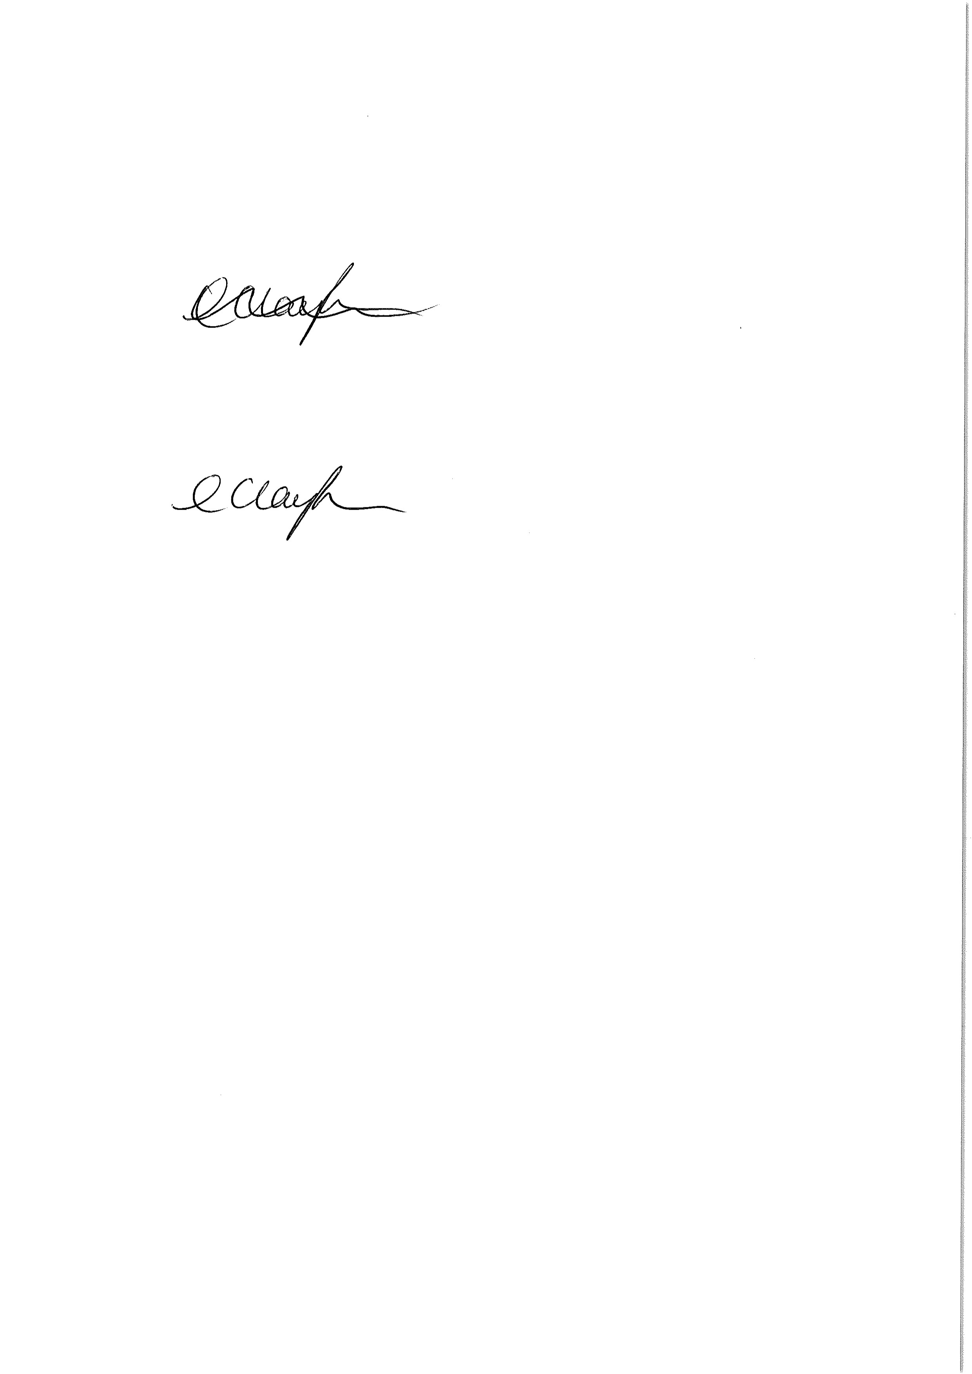
Signature: Date: 21/05/2025

NOTE:
You must within 28 days of becoming aware of any new personal interest or change to any personal interest specified above, register details of that new personal interest or change by providing written notification to the monitoring officer.

